**Date: 30.03.2025**

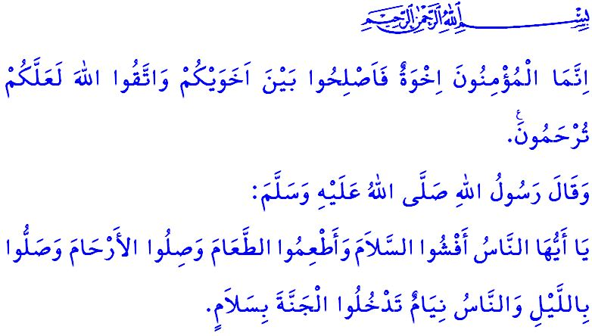**EID AL-FITR: DAYS OF JOY AND BROTHERHOOD**

**Honorable Muslims!**

Alhamdulillah, we have reached the morning of Eid after observing Ramadan, a month whose beginning is mercy, whose middle is forgiveness, and whose end is salvation from the torment of hell. May endless praise and thanks be to our Lord Almighty, Who has allowed us to reach this Eid al-Fitr. Peace and blessings be upon our beloved Prophet Muhammad Mustafa (saw), his Ahl al-Bayt, and his Companions, who taught us the value of eids, the symbols of Islam. Eid Mubarak! I wish you all a happy Eid al-Fitr!

**Dear Believers!**

Today is Eid. It is a day of joy, celebration, and happiness. Today is a day to embody the words of our Prophet (saw): **“Do not envy one another. Do not turn your backs on each other. Do not bear grudges or hatred against one another. O servants of Allah! Be brothers and sisters!”[1]**, and open our hearts to one another with sincerity, removing division and disunity from within.

Today is Eid. The days of Eid are an opportunity to pass on our sublime religion, Islam, the beautiful character of our Prophet (saw), and our customs and culture, nurtured by the Qur’an and Sunnah, to future generations. It is a day to uphold and preserve our national and spiritual values, those that define our identity and unite us as a nation.

**Esteemed Muslims!**

Today is Eid. The days of Eid are not meant for distancing ourselves from our parents, relatives, friends, or our brothers and sisters in need. On the contrary, the days of Eid are a time to attend to the needs of our parents, the reason for our existence, by honoring them, kissing their hands, and seeking their blessings. These are the days to offer kind words and a warm smile to our spouses, with whom we share the burdens of life, and to show care and compassion to our children. These are the days of peace and happiness, where we uphold sila al-rahim, and visit our relatives and neighbors, asking about their wellbeing in an effort to be among those who receive the glad tidings of the Messenger of Allah (saw), **“O people! Spread the salam among you, feed others, uphold the ties of kinship, and pray at night while people sleep, and you will enter paradise in peace.”[2]** These are the days of solidarity and sharing, when we knock on the doors of the needy, the sick, and the elderly, gently caress the heads of orphans, meet their needs, and fill their hearts with the joy of Eid. These are the days of mercy and supplication, when we visit the graves of our noble martyrs, our heroic veterans who have passed into the Hereafter, and our ancestors who have entered eternity, remembering them with compassion and mercy.

**Dear Believers!**

Today is Eid. Today is the day of compassion, when we set aside the resentments and grudges that burden our hearts, offering a hand to one another and uniting heart to heart, in accordance with the command of our Almighty Lord: **“The believers are but one brotherhood, so make peace between your brothers. And be mindful of Allah so you may be shown mercy.”[3]** Today is a day of tolerance and solidarity, where we show compassion and mercy towards one another, in accordance with the hadith of our beloved Prophet (saw), **“The believers are like a body in their love for one another, in mercy and compassion for each other. When one part of the body is in pain, the other parts share in the suffering.”[4]** Today is the day of brotherhood, where we support one another and uphold each other’s rights and responsibilities, in obedience to the command of Allah the Almighty, **وَاَط۪يعُوا اللّٰهَ وَرَسُولَهُ وَلَا تَنَازَعُوا فَتَفْشَلُوا وَتَذْهَبَ ر۪يحُكُمْ “Obey Allah and His Messenger and do not dispute with one another, or you would be discouraged and weakened...”[5]**

**Dear Muslims!**

While the joy and peace of this blessed Eid morning fill our hearts, unfortunately, our brothers and sisters in Gaza are distant from the joy and excitement of Eid. The cruel and brutal Zionists continue to massacre innocent people—men, women, children, and the elderly. They deny any right to life for our brothers and sisters. They prevent them from meeting even their most basic needs, denying them a morsel of bread and a sip of water. However, it must be remembered that oppression is never eternal. The wrongdoers will surely be defeated. **وَاللّٰهُ مُتِمُّ نُورِه۪ وَلَوْ كَرِهَ الْـكَافِرُونَ** **“Allah will ˹certainly˺ perfect His light, even to the dismay of the disbelievers.”[6]** The days will come when our brothers and sisters will celebrate days of Eid in joy, peace, and security. What falls upon us is to continue providing both material and moral support to our brothers and sisters. Our hearts are burning, and the language of our souls cries out as follows:

**O Muslims!**

A whole community is being annihilated in Gaza. How much longer will we wait to unite our strength and put an end to the oppression of the oppressors?

**O People!**

Humanity is dying in Gaza. How many more children, women, and innocent lives must be slaughtered before we can save our humanity?

I pray to our Almighty Lord that the heartfelt supplications we make and the cries of ameen poured out from our tongues on this Eid morning may be instrumental in strengthening our ummah consciousness and religious brotherhood, and in bringing to an end the blood and tears flowing in Gaza. I congratulate the entire Islamic world, and especially our great nation, on the occasion of Eid al-Fitr.

1. Bukhari, Adab, 57.
2. Tirmidhi, Sifat al-Qiyamah, 42.
3. Hujurat, 49/10.
4. Muslim, Birr, 66.
5. Anfal, 8/46.
6. Saff, 61/8.

   ***General Directorate of Religious Services***